**Bean Life Cycle Phases**

The lifecycle of a Spring bean consists of the following phases, which are listed below

* **Container Started:**The Spring IoC container is initialized.
* **Bean Instantiated:** The container creates an instance of the bean.
* **Dependencies Injected:**The container injects the dependencies into the bean.
* **Custom init() method:** If the bean implements InitializingBean or has a custom initialization method specified via @PostConstruct or init-method.
* **Bean is Ready:**The bean is now fully initialized and ready to be used.
* **Custom utility method:** This could be any custom method you have defined in your bean.
* **Custom destroy() method:** If the bean implements DisposableBean or has a custom destruction method specified via @PreDestroy or destroy-method, it is called when the container is shutting down.

***The below image demonstrates the Spring bean lifecycle:***

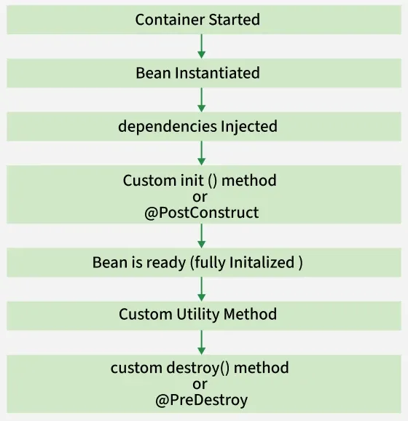

**Note:** We can choose a custom method name instead of **init()** and **destroy()**. Here, we will use init() method to execute all its code as the spring container starts up and the bean is instantiated, and destroy() method to execute all its code on closing the container.